PowerPoint Intro Activity—My License Plate
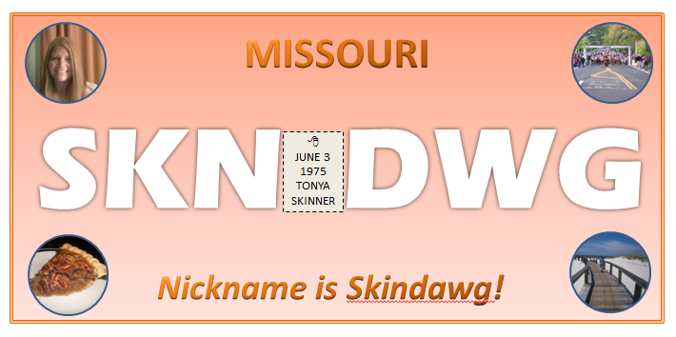
- Create a new PowerPoint file. Change the slide layout to blank. Save as MYLICENSE.PPTX to your U drive in your Computer Applications folder in a subfolder called Intro Activities. This will be a one slide PowerPoint (for now).
- Draw a Rectangle in the middle of the slide. Using the Drawing Tools, set the Size to 4.25” high by 9” wide. Then, Align to the center/middle of the slide.
- Change the Shape Fill to your favorite color. Then, modify the Shape Fill to be a Gradient. Select a Light Gradient of your choice.
- Change the Shape Outline to your favorite color. Then, modify the Shape Outline to be a 4 pt Double Line (HINT: Shape Outline, Weight, More Lines, set Width and Compound Type).
- At the top of the license plate, type the name of the state in which you were born. This should be created using a WordArt and font of your choice, All Caps (capitalized). Set font size to 44 pt. Set the Text Fill to a Gradient of your choice.
- Create your license plate “id letters” in the middle as a white filled WordArt. They need to represent you (your nickname, an acronym, or something that describes you) and should be three letters, a gap of two spaces, and three letters. Make this Eras Bold ITC font, size 115. It should fit in the box. Center align.
- Add your tagline at the bottom of the box by COPYING and PASTING your state name. Then, change the words to describe your “id letters” and change the size of the font in the bottom box to 36 pt and italic font style.
- Draw a Text Box in the blank area in between the “id letters” and give it black, dashed border. Then, type your birthdate and name (first and last) inside the box as shown. Size down the font so that your name fits. Then, using the Insert tab, insert a Symbol of your choice that is relevant to you. Finally, give the box a light gray fill.
- Now, some fun stuff! Go out to the internet and search for images of three of your favorite things—favorite candy/dessert, favorite sport or sports team/athlete, and favorite non-sports hobby OR favorite place. Save them to the Intro Activities folder. Also, take a picture of yourself (use the webcam!) and save it to that folder as well.
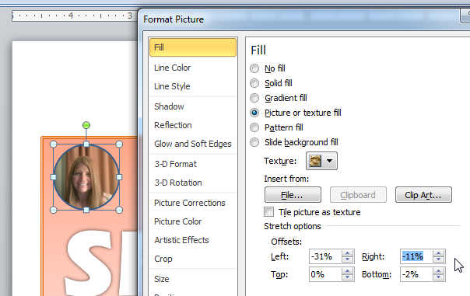
- Now, draw a circle in the top left corner of the license plate. Set the size to 1.1” by 1.1”. Then, modify the Shape Fill to Picture. Set the fill to the picture of yourself. Use any color border.
HINT: If it stretches it oddly, you can customize the stretch using Format Picture (right click the circle) and modifying the stretch options.
- Repeat this process, creating the same size circle in each corner. For the top right, set it to the sports picture. For the bottom left, use the candy/dessert, and for the bottom right, use the favorite hobby/place.
- Save! Go back down this list of instructions and be sure you did everything! Call me over for a screencheck of your work. I’ll record your progress on my class clipboard.

