Computer Applications
PowerPoint Unit 1 Concepts (Tutorial 1)
Start PowerPoint
- Open existing presentation
- Create a new presentation from a template
- Close a presentation, but not PowerPoint
- Save a presentation (with a new name)
- Choose slide layout (title + content, comparison, etc.)
Printing
- Full page slides (1 per page)
- Speaker notes (Notes Page)
  - Creating speaker notes
- Handouts (multiple slides per page)
- Grayscale
- Multiple copies
- Outline
- Scale to fit paper (print option)
Editing Text
- AutoCorrect (auto capitalize, fix misspelling)
- Undo (Control+Z and button)
- Edit text
- Zoom in/out (slider)
- Paste options (Keep Selected Text, Merge, etc.)
- Bold, italics, effects, shadow formats
- Copy/paste, Cut/paste, drag and drop to move, clipboard
Lists
- Create a multi-level bulleted list (tab method)
- Promote and demote bullets
- Indent one level
Animation/Transitions
- Animation a shape using entrance, emphasis, exit, motion path (Add Animation)
- Animate a bulleted list (by paragraph)
  - Bulleted list animation—“progressive disclosure” means one at a time (by paragraph)
- Apply transition to a single slide or to all slides
- Modify the start timing of animation (with, after previous)
- Add a sound to a transition
- Modify duration of transitions
- Use the Animation Painter (Animation tab, copies animation assigned, not object)
- Remove animation (More, to set to “none”)
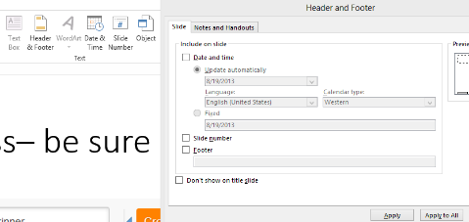
Insert Options and/or Master View
- Add footer to all slides except title slide
- Add date to all slides
- Display slides numbers
- Notes Master—set number of slides per page
- Slide Master—add features for all slides
- Outline View
- Reading View
Slides Pane (tab)
- Create a new slide with specific layout
- Duplicate a slide
- Delete a slide
Review Tab
- Check spelling
- Correct red underlined errors
- Use the Thesaurus
- Use the Research pane
- Use the Mini Translator
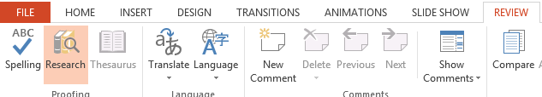Random Topics
- Slide Sorter View
  - Change the order of slides
- Run slide show from beginning
- Go to a specific slide during a show
- End slideshow
- Change theme (Design)
- Change stacking order (send to back, etc.)
- Autofit text to text box (Format Shape, Text Box)

